Project#5A

Inverse Gaussian Filter (IGF)

EE5356 Digital Image Processing

Textbook pages 256–258,

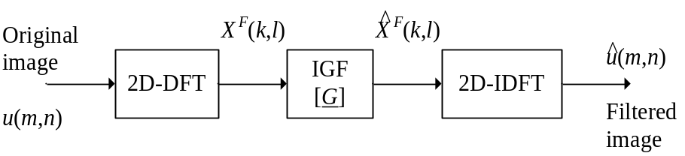

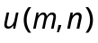, m, n=0,1,…..,N-1
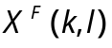, k, l=0,1,…..,N-1
are 2D-DFT coefficients

(5.65), page 147

(5.66), page 148

2D-DFT and 2D-IDFT (unitary) are defined in (5.63) & (5.64), page 146.
is the unitary DFT matrix.

Inverse Gaussian filter (IGF) is defined by 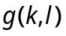 where
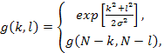
0≤k,l≤(N/2)

Otherwise (7.48), page 258

IGF emphasizes high frequency coefficients and restores images blurred by atmospheric turbulence or other phenomenon modeled by Gaussian point spread functions.

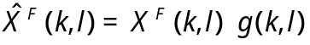 (7.47), page 256

2D-DFT coefficients are filtered in the frequency domain.

Apply IGF to the following images,

Lena (512×512), use 15707
Goldhill (256×256), use 28198
Boat (512×512), use 41694
Girl (512×512), use 34657

1) Display both original and filtered images.

2) Display the IGF (3D) using MATLAB commands,

surf(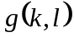, ‘EdgeColor’, ‘none’);
colormap(hsv);
shading interp;
alpha(0.7);
grid on;
axis tight;

(For more detail on Matlab commands, use help in Matlab.)

